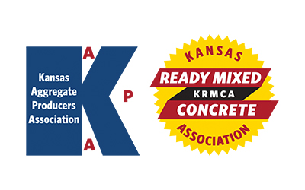
KAPA Research & Specifications (R&S)
KRMCA Technical and Quality Control (TQC)
Quarterly Committee Meeting
Thursday – February 2, 2023 - 1:30 PM
AGENDA

- Introductions

- Antitrust Statement / Approval of November 3, 2022 R&S/TQC Minutes

- Update from KDOT on efforts to structure an agency based concrete testing oversight program (similar to CTAC).

- Developing formal protocols for addressing low strength test results. KDOT questionnaire distributed to KRMCA membership.

- 2023 blind sampling and how to achieve desired outcomes using AWP.

- Options for current and anticipated issues with fly ash availability in 2023.

- Discussion on the need to update/adjust the KDOT Quarry Road Reimbursement Policy (attached).

- KDOT policy on existing concrete mix designs converting to Type IL cement. Confusion/misunderstanding about requirements (testing, resubmittals, etc.) amongst the different districts when switching to IL cement. Report from KDOT on their internal testing of IL cement.

- Discussion of KDOT process for approving aggregate material produced from road cuts on projects and variances from approval requirements for standard quarrying operations.

