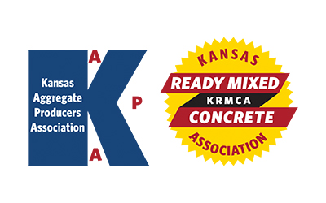
KAPA Research & Specifications (R&S)
KRMCA Technical and Quality Control (TQC)
Quarterly Committee Meeting
Wednesday – August 9, 2023 - 1:30 PM
AGENDA

1. Introductions

2. Antitrust Statement

3. Review and Approval of 5/8/23 R&S/TQC Meeting Minutes

Continued Discussion/Update from Previous Meeting

4. Concrete Testing Oversight Program

5. Protocols for Addressing Low Strength Test Results

6. Quarry Road Reimbursement Policy

7. 2023 Blind Sample Testing

8. AWP - OFQ Report

9. Updates from KRMCA members on fly ash availability

New Items

10. Wetting & Drying Spec (KTMR-23)

11. Later strength gain with 1L cement. COE specification. Expanded use of water reducers and/or plasticizers to mitigate. 1L issues.

12. Resistivity testing for concrete. Are all KDOT districts testing with the same equipment?
Issues with KDOT test results not aligning with producer/third party test results?

13. Potential use of Macadam type road construction of low volume county roads. Ability to produce aggregate that meets spec.

