KAPA-KRMCA’s

2019 SPRING LEGISLATIVE RECEPTION

(NEW LOCATION)
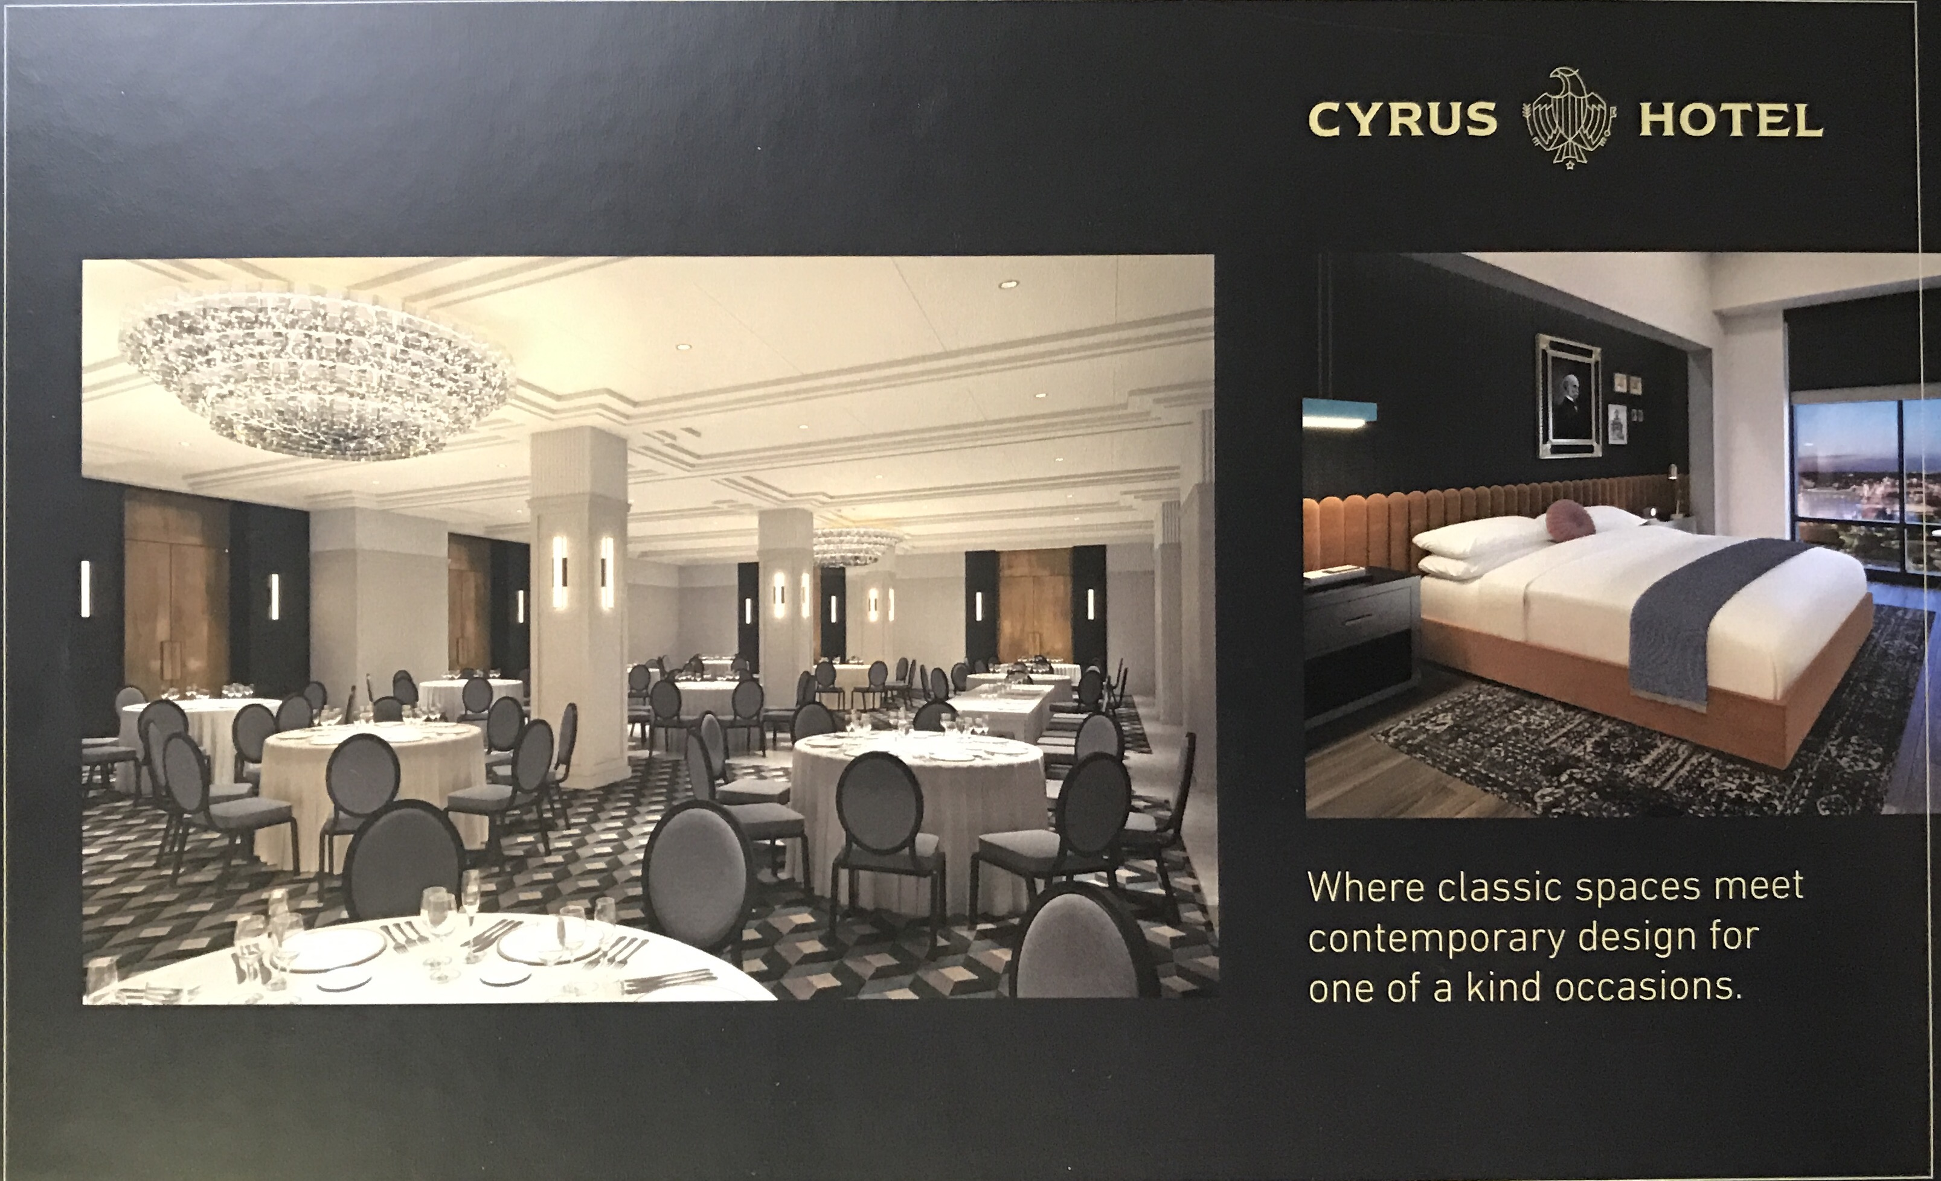
Thursday, March 21st, 2019
Cyrus Hotel – Cyrus Ballroom
920 S. Kansas Avenue/Topeka, KS
Membership Briefing @ 4:30 PM
All Legislator Reception from 5:00-7:00 PM

All members are encouraged to join us for our Annual Spring Legislative Reception.
This year we are excited to be hosting our reception at the newly opened Cyrus Hotel’s Ballroom; only a block away from the Capitol. There is No cost to attend for KAPA-KRMCA members but we do ask that you register online or complete and mail in the form located on the back of this invite.

*FOR THOSE WISHING TO STAY OVERNIGHT WE HAVE SECURED A BLOCK OF ROOMS AT THE HOTEL FOR $119
Please call the hotel directly and request the KAPA-KRMCA BLOCK RATE
Phone: 866-266-3500
KAPA-KRMCA
2019 SPRING LEGISLATIVE RECEPTION
THURSDAY, MARCH 21ST
5:00 – 7:00 pm
(Membership Briefing Starts @ 4:30 PM)
REGISTER ONLINE @ www.kapa-krmca.org OR Mail in Form by 3/15/19

ATTENDANCE FORM
The following representatives from our company will attend the Spring Legislative Reception
(NOTE: There is no charge for members to attend, Sponsorship Opportunities are available and appreciated)
- ______________________________________________________
- ______________________________________________________
- ______________________________________________________
Company Name: _______________________________________________________________
Contact Phone #: _______________________________________________________________
Contact Email: _______________________________________________________________

SPONSORSHIP FORM
KAPA-KRMCA is looking forward to providing this opportunity for our members to meet and discuss industry issues with legislators. KAPA-KRMCA members have always generously helped defer the reception cost through sponsorships. Please show your support by becoming a sponsor. All sponsors will be recognized at the reception.
YES, I WOULD LIKE TO SPONSOR THE 2019 LEGISLATIVE RECEPTION
- BRONZE SPONSOR ($200)
- SIVLER SPONSOR ($300)
- GOLD SPONSOR ($400)
- Company Name: _______________________________________________________________
- Contact Phone #: _______________________________________________________________
- Contact Email: _______________________________________________________________
- CHECK ENCLOSED
- PLEASE INVOICE ME

PLEASE RETURN FORM BEFORE MARCH 15TH TO:
KAPA-KRMCA / 800 SW JACKSON STREET, SUITE #1408 / TOPEKA, KS 66612

